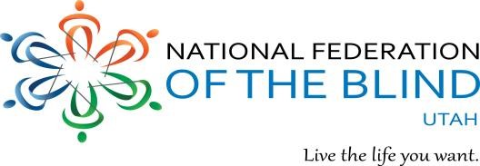
www.nfbutah.org Everette Bacon, President nfbutah@gmail.com 266 Elizabeth Street 801-463-6632 Salt Lake City, Utah 84102 baconev@yahoo.com

801-631-8108

Greetings,
Hello, I am a member of the National Federation of the Blind of Utah (NFBU). Our organization is comprised of blind and sighted members from around the state who are working to better the opportunities for blind and low vision people in our communities. We do this through advocacy, education, mentoring, and hosting programs that encourage independence and self-confidence. We would like to let you know about an opportunity to make a difference in the lives of blind people by contributing an in-kind donation or gift certificate to be used during our upcoming annual convention. The event will be held April 11-13, 2024 at the Salt Lake City Sheraton Hotel. Items donated will be used at an auction taking place at noon on Saturday, April 13.
We are raising funds during this auction to assist in several programs that will benefit blind and low vision people around the state. One of my passions for our work lies in our commitment to improving educational opportunities for blind students. Blind role models from our organization often meet with parents and school districts to help provide them with guidance on how to provide equal and meaningful education in the mainstream school system for a blind child. There is a high correlation between Braille readers and employment, as 90 percent of all employed blind people are Braille readers. NFBU runs a summer program for elementary students called Braille Enrichment in Literacy and Learning (BELL) Academy. This academy provides two weeks of hands on educational and social activities that use Braille skills and is run by blind adults. We also have a scholarship program which sponsors up to $10,000 in scholarships to blind college students in Utah. It is the largest of its kind in the state and we will award these scholarships at our banquet during the convention on the evening of Saturday, April 13.
Can you help sponsor an auction item with an in kind product, event ticket, or gift certificate from your company? All donations are greatly appreciated and are tax deductible. Any donation you make would be genuinely valued. The NFB of Utah is a charitable organization as defined by section 501(c) 3 of the Internal Revenue Code; our Federal Tax I.D. is 94-2579118. This makes your donation a tax-deductible contribution. We can make arrangements to pick it up from you by April 4, or it can be mailed to me directly, whatever is most convenient.
I would be happy to answer any questions about the National Federation of the Blind of Utah or about how else your gift will increase opportunities in your community. Thank you for your consideration and I look forward to hearing from you.

Enthusiastically,
National Federation of the Blind of Utah
Website: www.nfbutah.org
Email: nfbutah@gmail.com
Phone: 801-631-8108
The National Federation of the Blind knows that blindness is not the characteristic that defines you or your future. Every day we raise the expectations of blind people because we know that low expectations create obstacles between blind people and our dreams. You can live the life you want! Blindness is not what holds you back.

